**PROJECT REPORT**

**Design and Simulation of Circuits and Embedded Systems**

**INTRODUCTION**

1. [**Requirements**](https://github.com/sumeet2908/M1_Operations_Utility/tree/main/1_Requirements)
2. [**Architecture**](https://github.com/sumeet2908/M1_Operations_Utility/tree/main/2_Architecture)
3. [**Implementation**](https://github.com/sumeet2908/M1_Operations_Utility/tree/main/3_Implementation)
4. [**TestPlanAndOutput**](https://github.com/sumeet2908/M1_Operations_Utility/tree/main/4_TestPlanAndOutput)
5. [**Report**](https://github.com/sumeet2908/M1_Operations_Utility/tree/main/5_Report)
6. [**ImageAndVideo**](https://github.com/sumeet2908/M1_Operations_Utility/tree/main/6_ImageAndVideo)

**1.Requirements**

* **Requirements**
* **High Level Requirements**
* **Low Level Requirements**
* **SWOT**
* **4W's and 1H's**

**# Description**

**# Abstract**

**A Water Level Indicator is used to detect and indicate the water level in an overhead tank or any other water**

**container. In this paper, we investigated the design of a water level sensor device using Arudino UNO, that can**

**detect the level of water in a water storage system. An ultrasonic sensor is used to generate ultrasonic waves, a**

**water sensor to detect the water level, LEDs to signify the importance of different water levels, PC to observe the**

**levels of water. We indicated a green LED for safe water level, one red LED for about to reach max level and two**

**red LEDs for maximum water level. This circuit is efficient and can be used for any application involving the**

**levels of any liquid**

**# Features**

**1) Save Power: In an era of energy conservation, these devices are very beneficial to save energy. Hence**

**electrical power wastage can be reduced. These sensor control water levels and minimize the usage of**

**electricity**

**2) Automatically works: These sensors can work automatically when connected to timer devices.**

**3) These are low cost and easy to install devices**

**4) The design is compact and with low maintenance and cam clearly indicate the water levels in the overhead**

**tank**

**5) AS they can be fully automatic, they save time and avoid seepage of roofs and walls due to overflowing tanks.**

**6) These sensors take less energy and can be used for continuous operation**

**# Block diagram**

**![Blank diagram (1)](https://user-images.githubusercontent.com/98872208/155832144-91d243e5-b589-4469-88f5-b14950d40e6a.png)**

**# Components**

**## Arduino UNO**

**the uno is a great choice for your first arduino. it's got everything you need to get started, and nothing you don't.**

**it has 14 digital input/output pins 6 analog inputs, a usb connection, a power jack, a reset button and more. it**

**contains everything needed to support the microcontroller; simply connect it to a computer with a usb cable or power**

**it with a ac-to-dc adapter or battery to get started.**

**## Water level sensor**

**Level sensors are used to detect the level of substances that can flow. Such substances include liquids, slurries, granular**

**material and powders. Level measurements can be done inside containers or it can be the level of a river or lake.**

**## Connecting wires**

**Connecting wires allows an electrical current to travel from one point on a circuit to another because electricity needs**

**a medium through which it can move. Most of the connecting wires are made up of copper or aluminum**

**## LED lights**

**An electrical current passes through a microchip, which illuminates the tiny light sources we call LEDs and the result is**

**visible light.**

**## Servo-motor**

**A servomotor (or servo motor) is a rotary actuator or linear actuator that allows for precise**

**control of angular or linear position, velocity and acceleration.**

**## potentiometer**

**A potentiometer is a three-terminal resistor with a sliding or rotating contact that forms an adjustable voltage divider.**

**If only two terminals are used, one end and the wiper, it acts as a variable resistor or rheostat.**

**## Resistors**

**It is a device that has electrical resistance and that is used in an electric circuit for protection, operation, or current**

**control.**

**## Requirements**

**## High Level Requirements**

**|ID | Description**

**|HLR1| Circuit should have to work 24 hour's**

**|HLR2| It should detect the water level accurately**

**|HLR3| Led should glow properly.**

**|HLR4| Sensor should sense the water level.**

**|HLR5| Servo-motor should ON/OFF properly.**

**## Low Level Requirements**

**| ID | Description**

**|LLR1| Motor valve should be open when water is less.**

**|LLR2| Aurdino will sense the signal properly.**

**|LLR3| Sensor send the signal to aurdino.**

**|LLR4| Motor valve should be close when water is full.**

**|LLR5| Led should glow green when valve is open**

**# SWOT**

**## Strength**

**\* It can detect the water level accurately**

**\* Highly reliable and Economically competitive.**

**\* Enhanced Security of Urban Water supply and Water use efficiency.**

**## Weakneses**

**\* It cannot be used everywhere**

**\* The automatic water level controller shows poor durability.**

**\* When a problem arose, there is no built-in function to help identify the source of the failure.**

**\* Water level controls need to be replaced every 3 years.**

**## Oppourtunities**

**\* Rapidly growing adoption of smart applications.**

**\* It Develops Water Saving Technology.**

**\* Maximize Water supply Benefits and provide balanced allocation of water resources.**

**## Threats**

**\* The circuit can be protected protected from water and moisture.**

**\* Skills for repair/spare parts not available in most of the areas.**

**\* Any sort of defect or fault in the circuit will cause problem in water supply.**

**# 4W's and 1H's**

**\* Who**

**\* Everyone can use this circuit**

**\* What**

**\* It measure the water level**

**\* When**

**\* It can be used when we want to**

**\* Where**

**\* Industry,home,offices etc**

**\* How**

**\* it can detecting by using ultrasonic sensor**

**# Applications**

**\* Hotels and restaurants, residential as well commercial complexes, factories, drainage etc can use these**

**water level indicators. They can be fixed for any motor as they can be easily amalgamated into any circuit.**

**\* These sensors can be used as fuel level indicators in vehicles and as liquid level indicators in chemical**

**industries.**

**\* It can be used in Oil tank Level Control.**

**\* It can also be used in Sewage pump level control.**

**2.Architecture**

* **Flowchart**
* 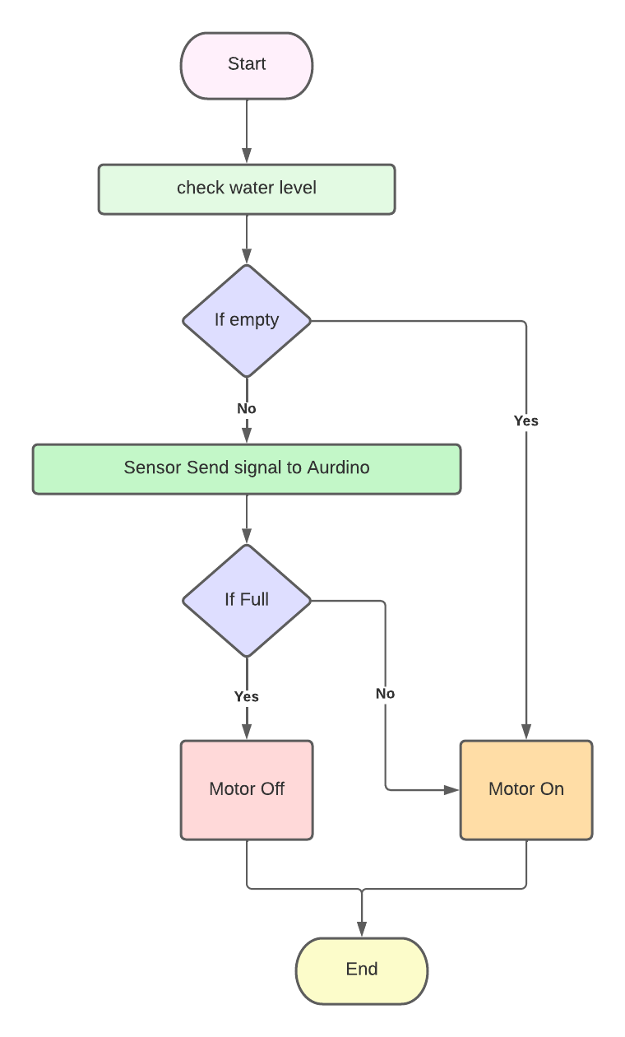
* **Behavioural**

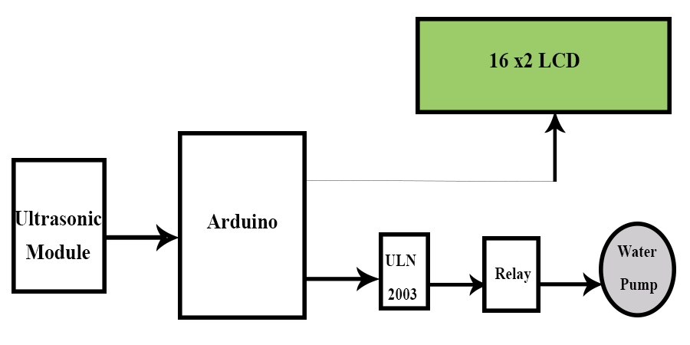

1. **Implementation**

* **Elf file**
* **Hex file**
* **Ino file**
* **Simu file**

1. **Test plan and Output**

|  |  |  |  |  |  |  |  |  |  |
| --- | --- | --- | --- | --- | --- | --- | --- | --- | --- |
| ID | DESCRIPTION | | | EXPECTED INPUT | | EXPECTED OUTPUT | | TEST CASE | |
| HR01 | Servo motor should ON/OFF | | | Power supply | | Servo Motor will ON/OFF | | Passed | |
| HR02 | Ultra-sonic sensor should sense the water level | | | Water should be there in the tank to sense the level of water | | Sensor will sense the water level in the tank | | Passed | |
| HR03 | LED should glow RED/GREEN | | | After sensing Arduino will glow LED red or green | | Red/green LED should glow | | Passed | |
| HR04 | Voltmeter should measure the voltage | | | Potentiometer | | Voltmeter will show the readings according to the potentiometer | | Passed | |
|  |  | | |  | |  | |  | |
| ID | | DESCRIPTION | EXPECTED INPUT | | EXPECTED OUTPUT | | TEST CASE | |
| LR01 | | Servo motor valve should be open when the water is less. | Less water level | | Servo motor will ON | | Passed | |
| LR02 | | Servo motor valve should close when water is full. | Full water level | | Servo Motor will OFF | | Passed | |
| LR03 | | LED should glow Red when valve is open. | Taking input from Arduino | | Red LED will glow | | Passed | |
| LR04 | | LED should glow green when valve is closed. | Taking input from Arduino | | Green LED will glow | | Passed | |
| LR05 | | Potentiometer should regulate the voltage properly | 5V supply | | Voltmeter will show the reading. | | Passed | |

1. **Report**
2. **ImageAndVideo**

* 